The Clock is Ticking: Are Your Contract Terms Out-of-Date for Transfers of Personal Data Subject to the GDPR?

Does the European Union (“EU”)’s General Data Protection Regulation (“GDPR”) apply to your contracts’ transfers of Personal Data from the European Economic Area (“EEA”) to a country (such as the United States) that the EU deems to lack “adequate” safeguards?

- If so, do you rely on contract terms to permit such cross-border transfers?
- If yes, it’s time to check your contracts – do they have the current SCCs for international transfers ((Commission Implementing Decision (EU) 2021/914, aka “new” SCCs”)?
  - The grace period to transition from earlier SCC versions (where entered into by September 27, 2021) ends December 27, 2022.

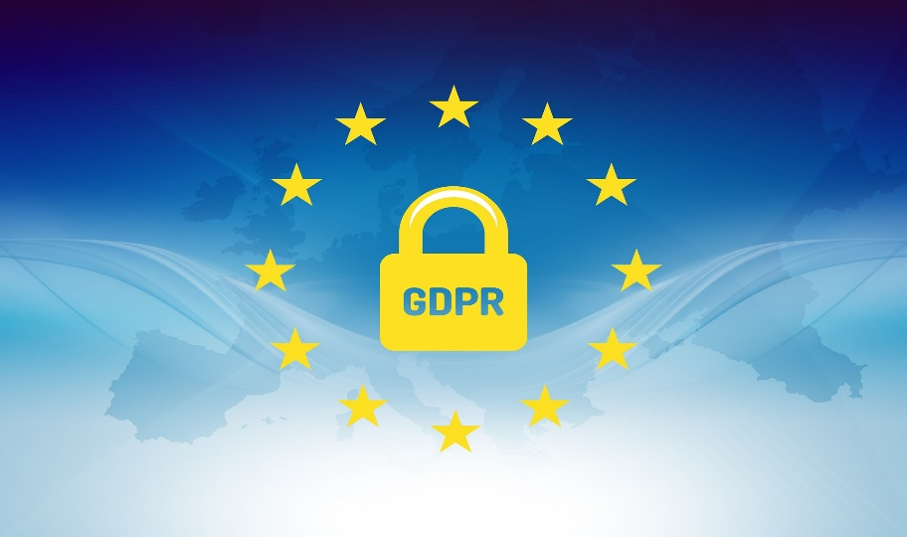

- Here’s a link identifying which countries the EEA currently deems “adequate.” The US is not among them: https://ec.europa.eu/info/law/law-topic/data-protection/international-dimension-data-protection/adequacy-decisions_en

- If you proceed with such transfers, do so with eyes open. While far beyond the scope of this brief blog post, know there are:
  - Operational choices to be made/negotiated within the SCCs (including selection of appropriate module(s), handling of subprocessors, governing law and jurisdictions); Annexes to be populated (in detail); obligations (notably including conducting and documenting a transfer impact assessment).
  - And, ongoing legal challenges (e.g., Schrems II and its progeny), with no guarantee such cross-border transfers will be found to comply with the GDPR even when using “new” SCCs, incorporating “supplementary measures,” or if/when the proposed Trans-Atlantic Data Privacy Framework comes to be.
  - See, e.g.: the European Commission’s Q&A about implementing the new SCCs: https://ec.europa.eu/info/law/law-topic/data-protection/international-dimension-data-protection/standard-contractual-clauses-scc_en; and articles by Mr. Schrems’ advocacy non-profit: https://noyb.eu/en/austrian-dsb-eu-us-data-transfers-google-analytics-illegal; https://noyb.eu/en/open-letter-future-eu-us-data-transfers

- What about the UK? Are the clauses the same, or the deadlines the same, for Persona Data transfers subject to UK Data Protection Laws? No. Thank Brexit. See: https://www.techcontracts.com/2022/03/29/contract-terms-current-uk-idta/.

Need training about tech contracts? Data management is among the topics addressed in Tech Contract Academy’s comprehensive, four-class series of on-line Tech Contracts Master Classes™: https://www.techcontracts.com/tech-contracts-master-class-registration/

